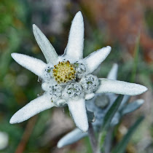

**The Flora of Central European Alps**

This mission welcomes all your observations of Central European alpine flora. This includes flowers, shrubs and trees. Essential to this mission is the recording of the exact date and location of your spotting, so make good use of Project Noah’s geo-mapping abilities by dropping the location pin as accurately as possible at the place where you saw the plants. Where possible include a description of soil, pictures of leaves to help with identification, indicate the presence of snow, and record the presence of nearby species/habitat. At this stage this mission and centered around the Swiss Alps and Prealps and nearby alpine/prealpine areas of France, Italy, Austria, Germany, Lichtenstein and Slovenia. Only wild, non-cultivated flora please.